Using and Navigating the FUMC Governance SharePoint Site

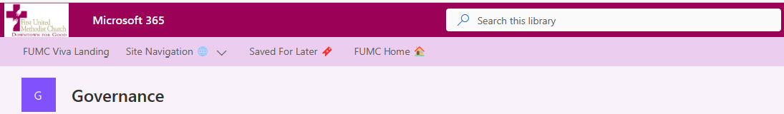

Link: Governance - Documents - All Documents (sharepoint.com)

https://fumcorg.sharepoint.com/sites/Governance/Shared%20Documents/Forms/AllItems.aspx

Consider saving the link as a favorite in your browser to get to it easily in the future.
You may receive direct links to specific documents or folders within this site as part of committee work.

GENERAL INFORMATION

Background
The Governance SharePoint site has been established to provide centralized cloud storage and document sharing for documents associated with various church committees. The goal is to provide a single location for committee members to find pertinent documents. Instead of copies of documents, links will be shared to documents.

Email Prompt
When you click on the link, you may be prompted to “Pick an account” to use. Select your email account.

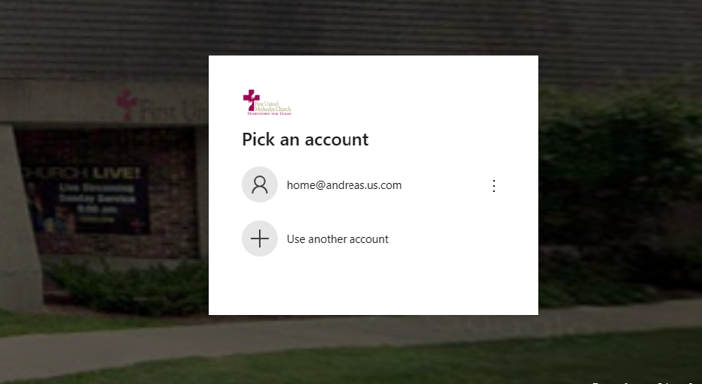

Access
Note that access is limited to specific individuals who have been granted access to the Governance site. Those with access can see documents in all folders they have been granted access to. Confidential information (e.g. documents related to staff) should not be added to the Governance SharePoint site.

To request access to the site, contact Ben McKnight (bmcknight@fumc.org).

Actions
Anyone with access to the site may add, upload, edit, move, or delete documents. SharePoint maintains a log of who performed these actions. In some cases, previous versions may be able revert to prior versions of a document.

SharePoint allows multiple people to view and edit a document at the same time; no need for separate documents

NAVIGATION AND USE

Error Messages on Header Items
You may receive a “Sorry, You don’t have access” message when you click on some items in the header on the site such as FUMC Viva Landing and the G in Governance. The error gives you the ability to request permission, but those functions are for administrative use only. Simply hit the back button on your browser to return to the spot you were previously viewing.

Documents and Folders
All documents are stored in folders. There is a top-level folder for Committees as well as a shared General Resources folder. Only administrators can add folders at this level.
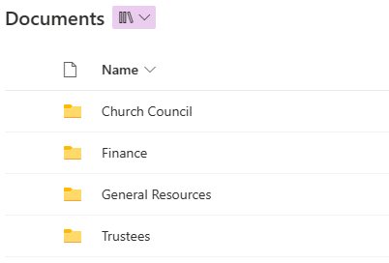

As you navigate through the folders by clicking on them, SharePoint will display a “breadcrumb” trail to show the folder structure. You can easily return to a higher level folder by clicking on the folder in the breadcrumb trail. In the example below you can click on Documents to return to the top-level folder structure.

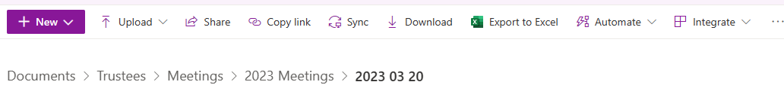

How to..
Hover over a document and then click on the three dots next to a document name to bring up the menu of all actions you can perform on the document. Click on the action you wish to perform and follow any prompts to complete the action. The following table lists common actions you may wish to perform on a document.

View Documents | Click on a document name to open the document.  - In some instances, the document will open in the same window in which you were viewing the folder. To return to the folder, hit your browser back button.  - In other cases, SharePoint will open the document in a separate browser tab. This generally occurs for editable documents like Word and Excel. To close the document and return to the folder you were viewing, close the tab. If you made changes they may be automatically saved.  You can also hover over document and then click on the three dots next to a document name to bring up the menu of actions you can perform on the document. Click Open or Preview.
Save Documents | SharePoint will automatically save documents as you make changes. No need to save separate copies of documents.  Keep this autosave functionality in mind as you are in Word or Excel documents. You may inadvertently make changes that are saved to a document. In Excel documents, actions such as hiding columns or filtering data may be registered as a change to the document. See Version History below.
Add Documents | Documents can be added in a couple of ways:  - Click the  button to bring up a menu of document types that can added. Click on Word to start a blank document. SharePoint will autosave the document. If it saves with a generic “doc” name, see instructions below to rename the document.  - Click the  button if you have a document stored on your computer that you want to copy into the SharePoint. Follow the prompts to navigate to your document and save in SharePoint.  Note: Documents will be added to the folder you are currently viewing.
Add a Folder | Click the button and select Folder. This will add a new Folder within the folder you are currently viewing. Follow the prompts to name the folder and navigate to it by clicking on it.
Edit in Application | When you click on a document, you can edit in the browser. Sometimes it is more efficient to work in a desktop version of Word or Excel rather than the browser. Open the document from SharePoint and then click on the Editing Dropdown. Select Open in Desktop App. When you exit the document, your changes will be saved in SharePoint.
Share a Link to a document | Hover over document and then click on the three dots next to a document name to bring up the menu of actions you can perform on the document. Click “Copy Link”. Click on Copy in the pop-up window. You can then paste that link into an email. People who have access to the FUMC SharePoint will be taken directly to the document without having to navigate to the document.  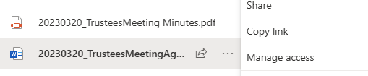
Search for a Document | SharePoint Searching is quite powerful. It can find words that are part of a document name or within the body of a document. The search tool will traverse the folder structure starting at the folder you are viewing and moving “down”. It will not go up unless you select higher folders in the breadcrumb trail.    To clear the results click the arrow in the search box to return to the folder you were previously viewing.
Version History  View or Retrieve a previous copy of a document | SharePoint maintains a limited number of versions of a document which can be viewed and retrieved.  Hover over document and then click on the three dots next to a document name to bring up the menu of actions you can perform on the document. Click on Version History. Hover over a version and click on the dropdown arrow to view the actions that can be taken on a specific version.  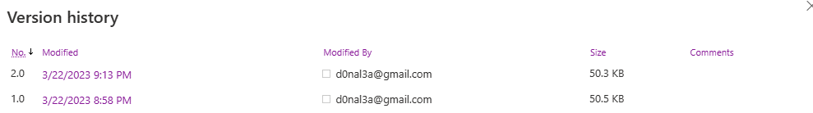
Rename a document | Hover over document and then click on the three dots next to a document name to bring up the menu of actions you can perform on the document. Click on Rename to change the current name of a document.
Save a Document to my Computer | Hover over document and then click on the three dots next to a document name to bring up the menu of actions you can perform on the document. Click Download and follow the prompts to save on your computer.
Move or Copy a file to a different SharePoint folder | It is best to have a single version of documents. Move and Copy operate as similar but different actions:  - As implied in the name, MOVE will take the current document and store it in another folder. This is useful if a document was saved in the wrong folder.  - COPY will generate a duplicate document in a separate folder but retain the current document. This is useful for generating a new version of a monthly agenda and starting with an existing document for structure.  These functions are available on the actions menu (…) for a document. Follow the prompts to complete the action.

